|  |
| --- |
|  |
| Cloud Computing – group assignment 1. |
|  |

|  |
| --- |
| Emiliano Rroshi, Mariusz Cichon, Victor Rodriguez  02.06.2021 |

Table of Content

1. Cloud Computing. 3

2. Task 1. 7

2.1. Identity & access Management (IAM) 7

2.2. Users and groups. 11

2.3. Amazon Elastic Compute Cloud (EC2) 25

2.4. Launching an Amazon EC2 Instance by admin. 31

2.5. Elastic Beanstalk service. 41

3. Task 2. 42

4. Task 3. 43

5. Conclusion. 44

6. Referencing. 45

7. Table of figures. 47

|  |  |  |  |  |  |  |  |
| --- | --- | --- | --- | --- | --- | --- | --- |
|  |  |  |  |  |  |  |  |
| **Student ID Number**  *(Do not include student name as anonymous marking is implemented)* | **CIC18465747, RRO18465894, Victor** | | | | | | |
| **Programme Title** | **BSc Computing Technologies Extended Degree (QA)** | | | | | | |
| **Module Title** | **Cloud Computing** | | | | | | |
| **Module Code** *(listed on Moodle and in LTAFP)* | **QAC020N254H** | | | | | | |
| **Module Convenor** | **Masum Billah** | | | | | | |
| **Coursework Title** | **Cloud Computing – group assignment 1.** | | | | | | |
| **Academic Declaration:**  *Students are reminded that the electronic copy of their essay may be checked, at any point during their degree, with Turnitin or other plagiarism detection software for plagiarised material.* | | | | | | | |
| **Word Count** |  | | | **Date Submitted** | | **Deadline**  **06/07/21** | |
|  |  | | |  | |  | |

# Cloud Computing.

Cloud computing (CC) is the distribution of servers, storage, databases, networking, software, analytics, and intelligence services over the internet, to propose quick and elastic resources and economy on a pay-as-you-go basis (Microsoft Azure, 2021). CC is counted in billions, and it is constantly growing over the years (Feldman, 2019); moreover, according to Alleyne (2021) incoming technology “5G” will boost storing, moving, and accessing data within CC.

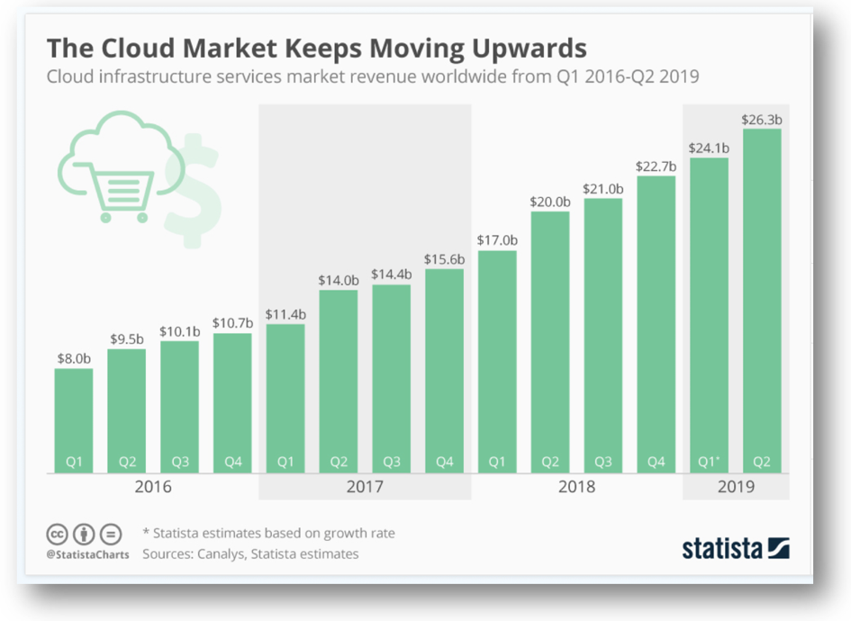

Figure . CC growth in 2016-2019 (Feldman, 2019).

There are seven reasons, that many organizations deciding to use CC services: cost, global scale, performance, security, speed, productivity, and reliability (Microsoft Azure 2021).

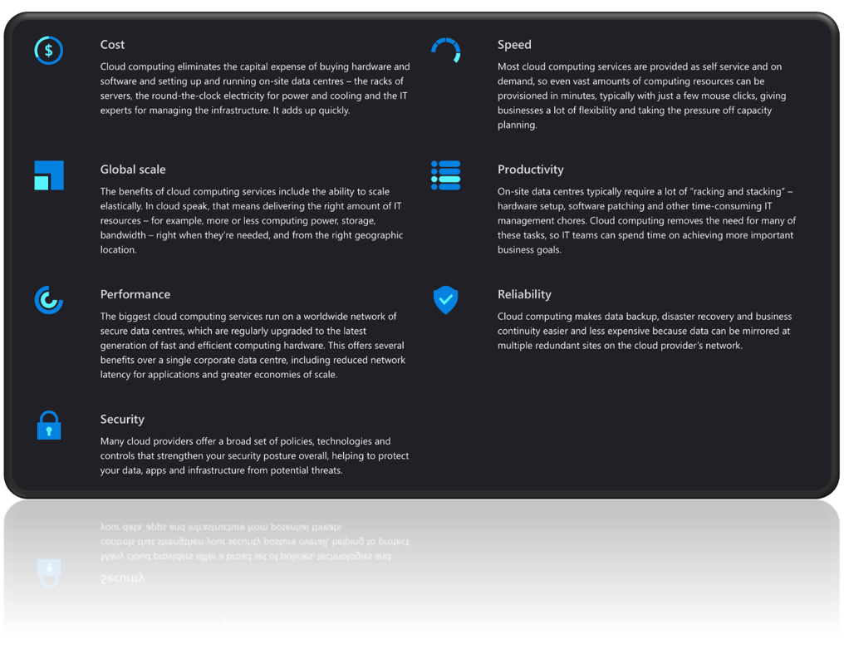

Figure . Detailed reasons of CC's growth (Microsoft Azure, 2021).

There are many cloud providers on the market, but still the major influence in growth is associated with amazon.

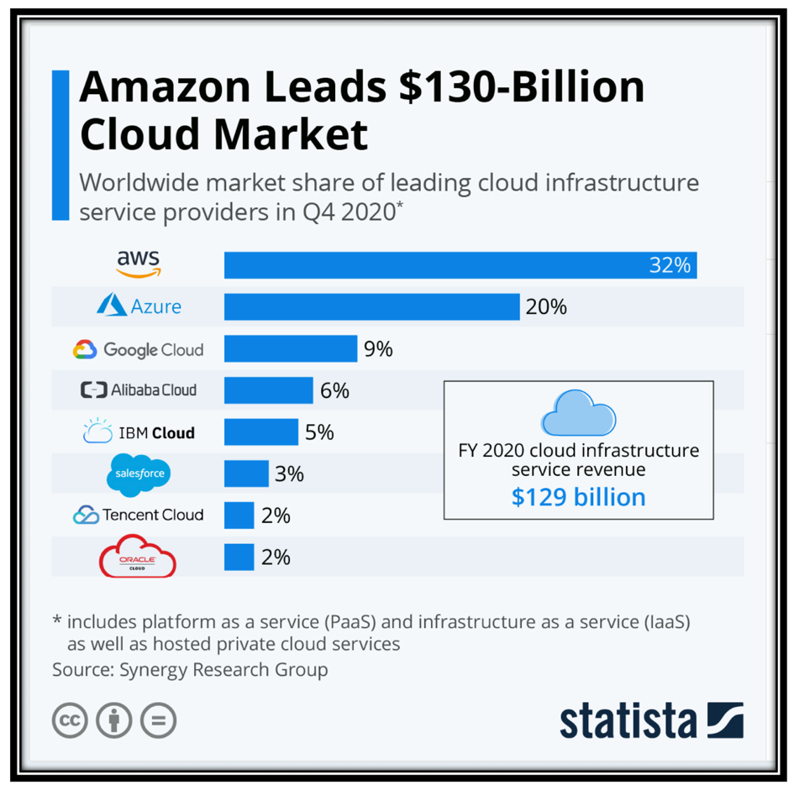

Figure . Cloud market leaders (Richter, 2021).

According to Carey (2020) the dominance of Amazon Web Services (AWS) on the cloud market is due the variety of services. AWS owned nearly 200 services and 22 regions, where servers are located (Poccia, 2020).

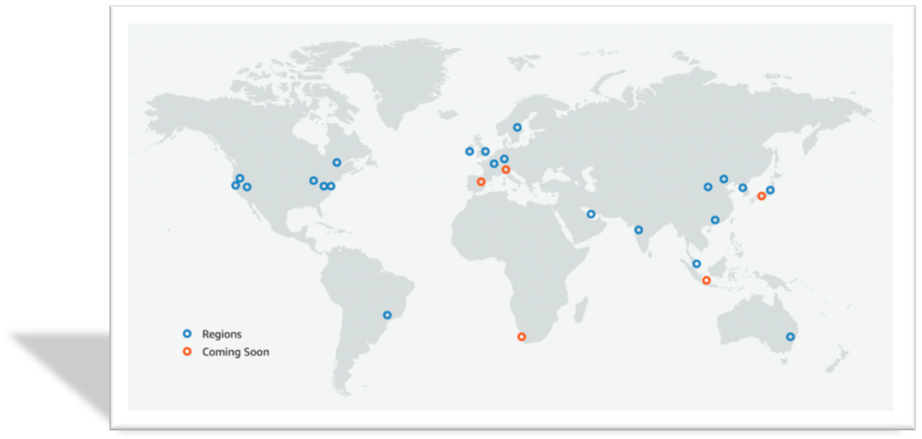

Figure . AWS regions (Poccia, 2020).

# Task 1.

## Identity & access Management (IAM)

According to Nikolaisen (2021) **IAM** is form on user identities, which include user authentication and authorization; moreover, it is responsible for central management, user access and privileges within systems, applications, and cloud.

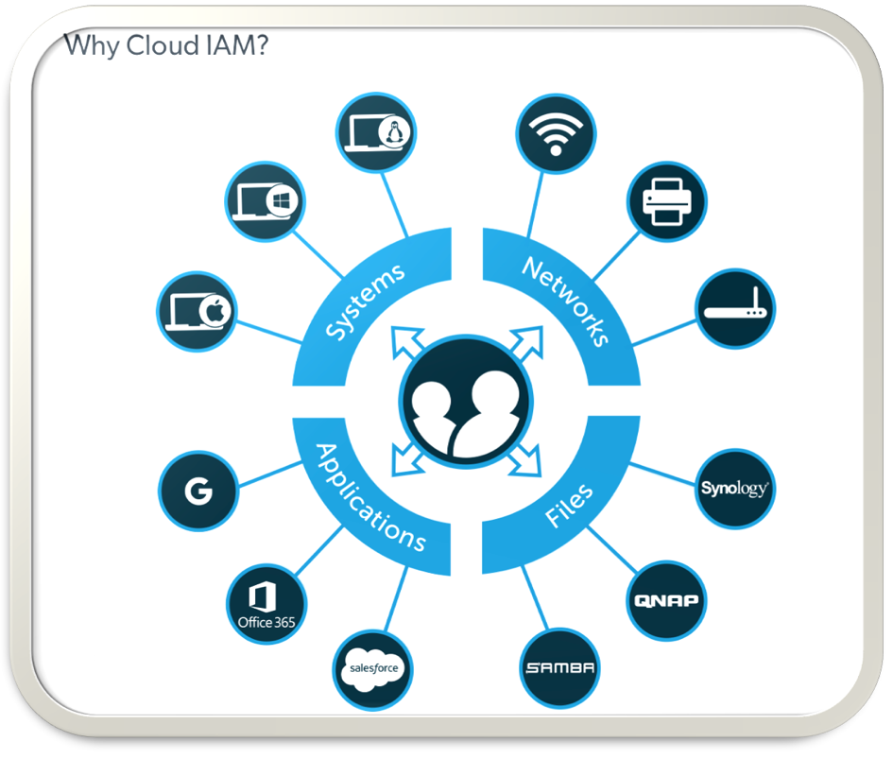

Figure . Why cloud IAM (Lujan, 2018).

IAM have 4 key concepts:

1. **Users** – specific individual with password.
2. **Groups** – selection of users.
3. **Roles** - collection of policies.
4. **Policies** – low level permissions/privileges to AWS resources.

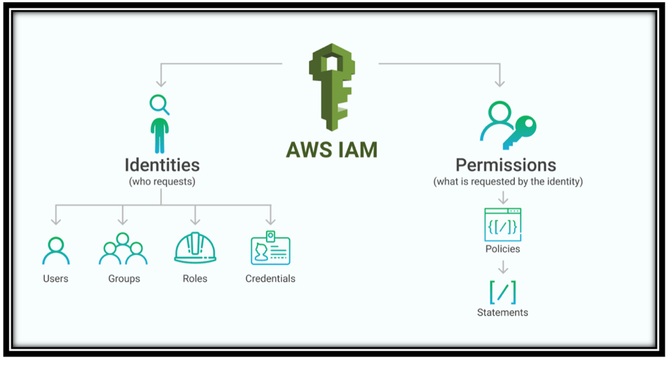

Figure . Key concepts (DeBrie, 2018).

IAM offer a variety of functionalities.

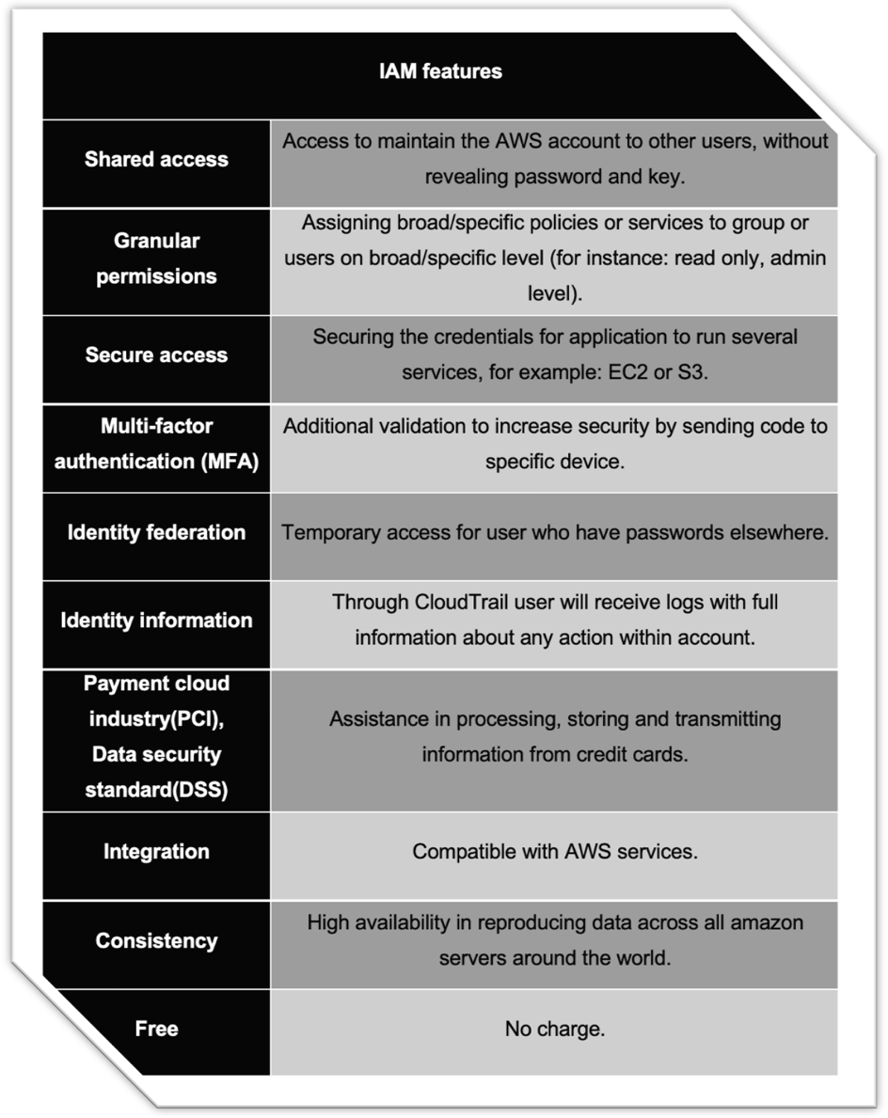

Figure . IAM features (AWS, 2021a).

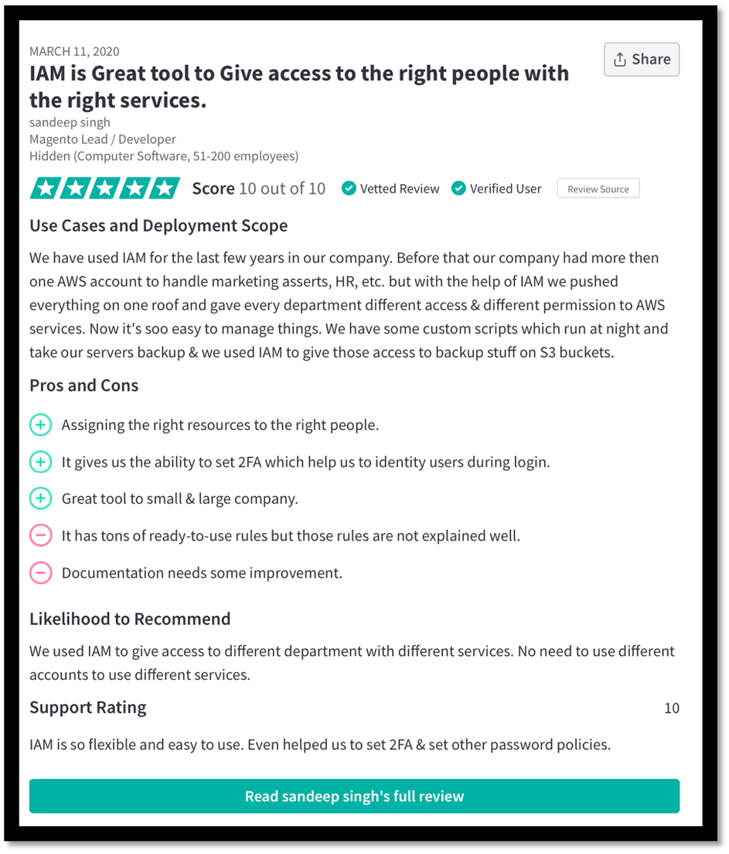

Figure . IAM review (TrustRadius, 2021a).

Pros and cons:

+ good control of user access.

+ privileges are based on single policies.

+ decreasing the effort, time, and money for IAM management.

- documentation needs improvement.

## Users and groups.

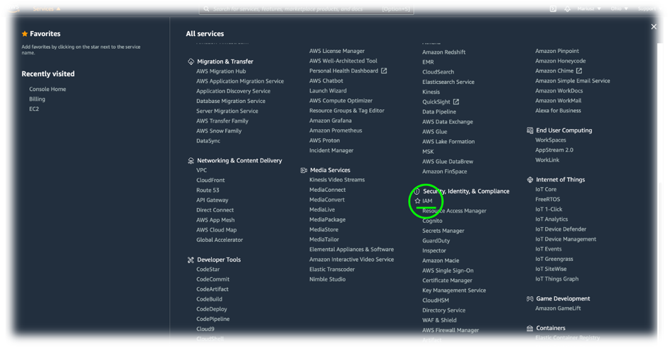

Figure . Choosing IAM from services.

Due to occurrence of additional charges the region remain default.



Figure . Region.

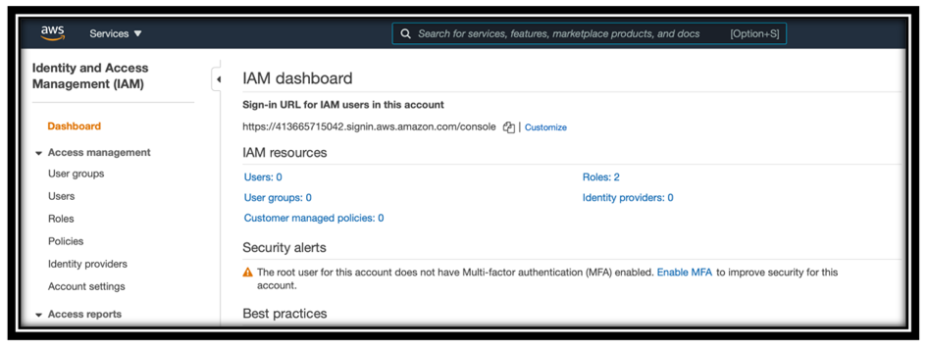

Figure . IAM dashboard.

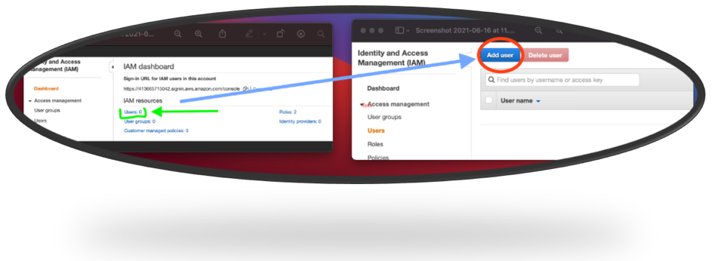

Figure . User creation.

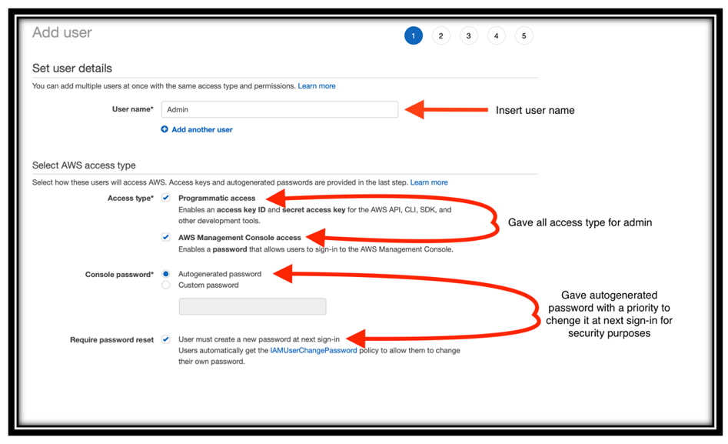

Figure 13. Step one for admin creation.

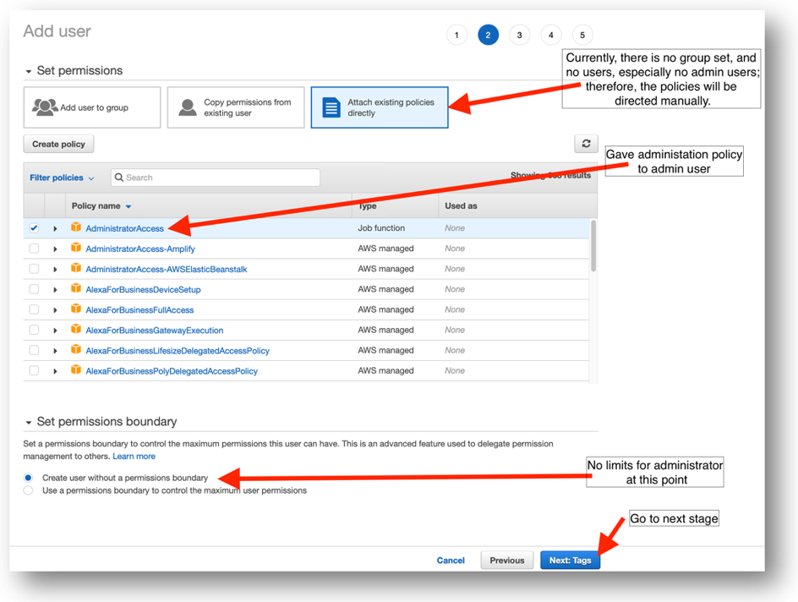

Figure 14. Step two.

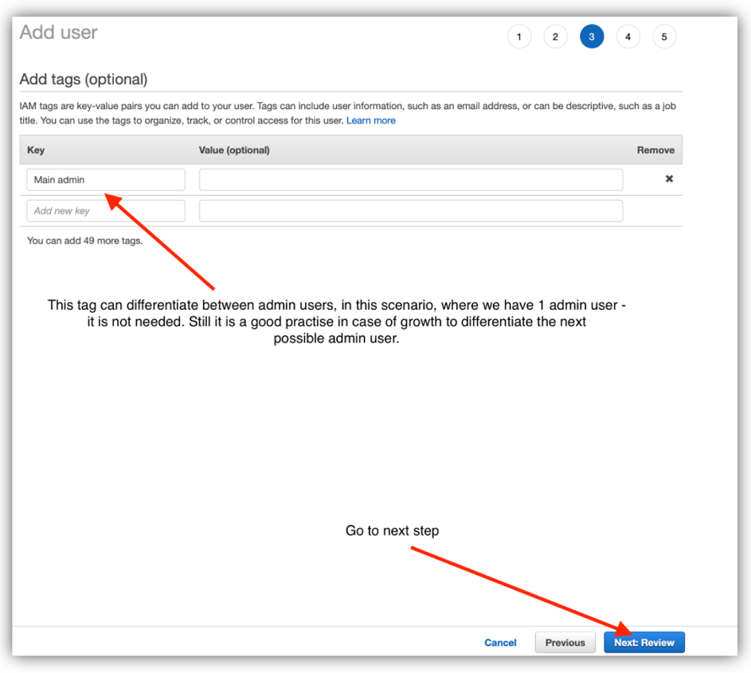

Figure 15. Step three.

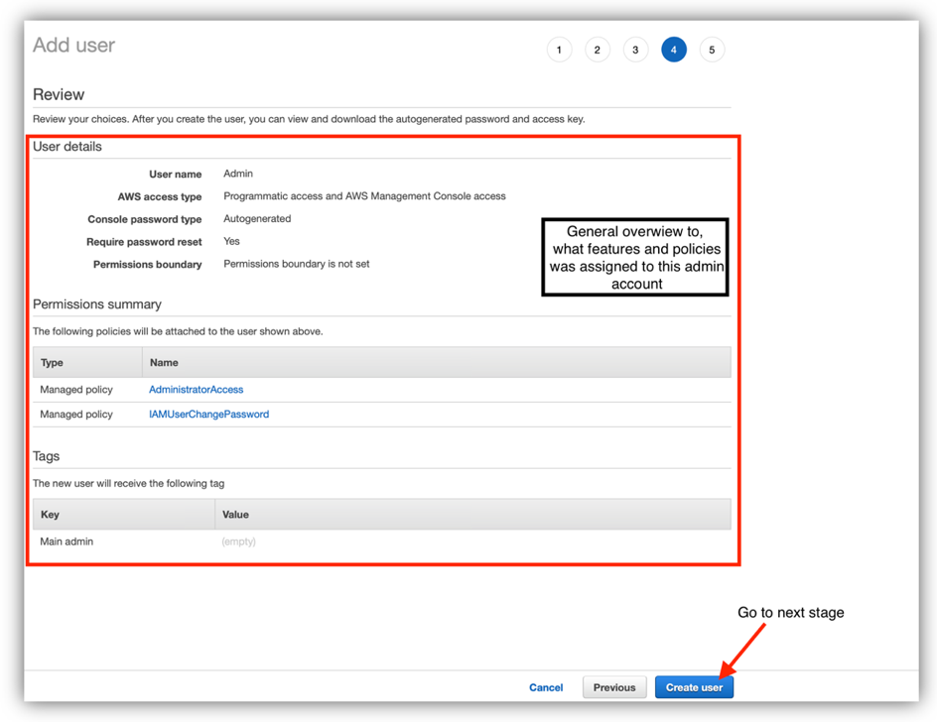

Figure 16. Step four.

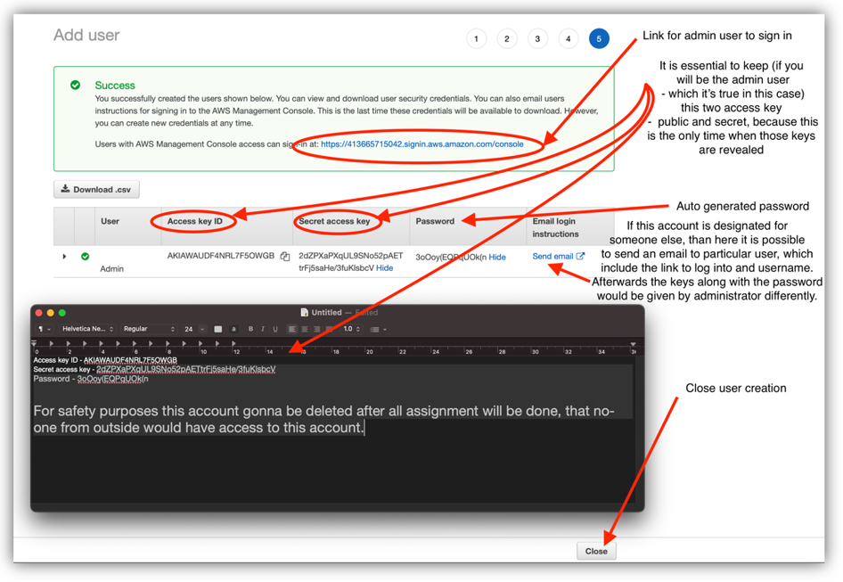

Figure 17. Step five.

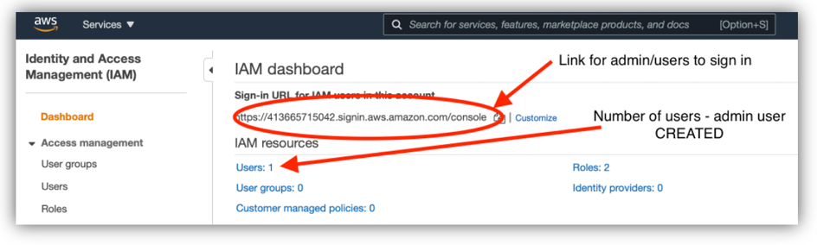

Figure 18. Confirmation.

**From this point, root account is no longer needed – all the configurations will be done from administrator account.**

Figure 19. Step one for no-admin user creation.

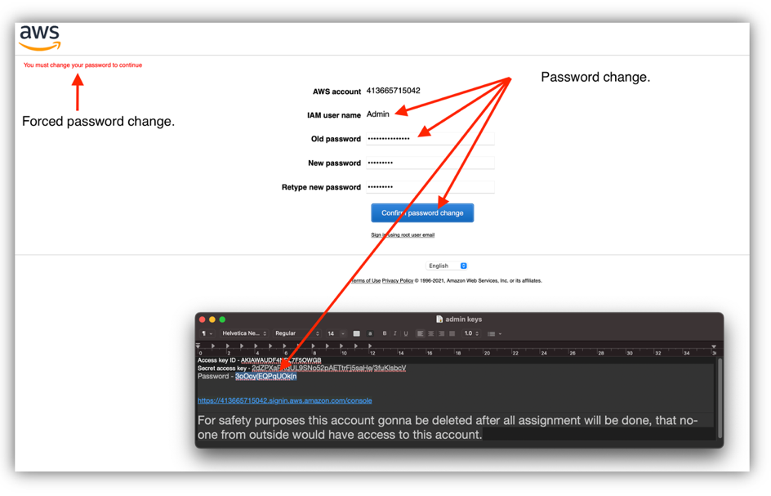

Figure 20. Step two.

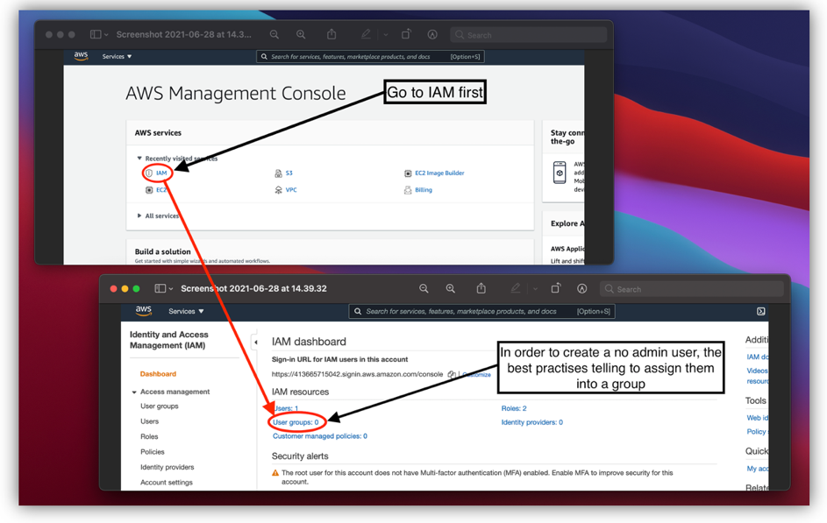

Figure 21. Step three.

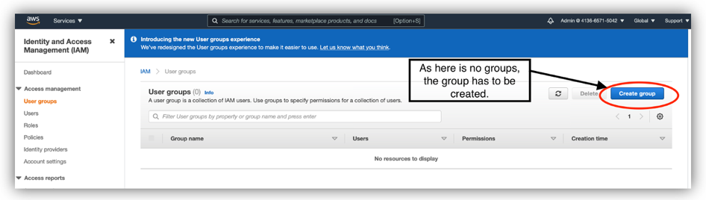

Figure 22. Step four.

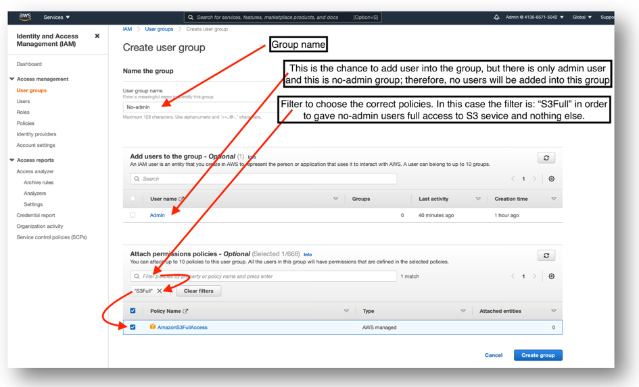

Figure 23. Step five.

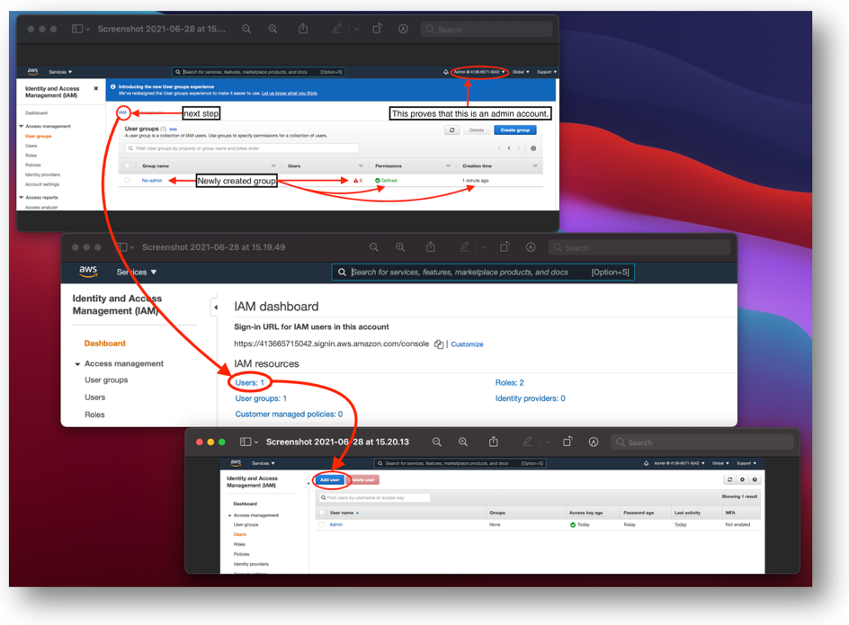

Figure 24. Step six.

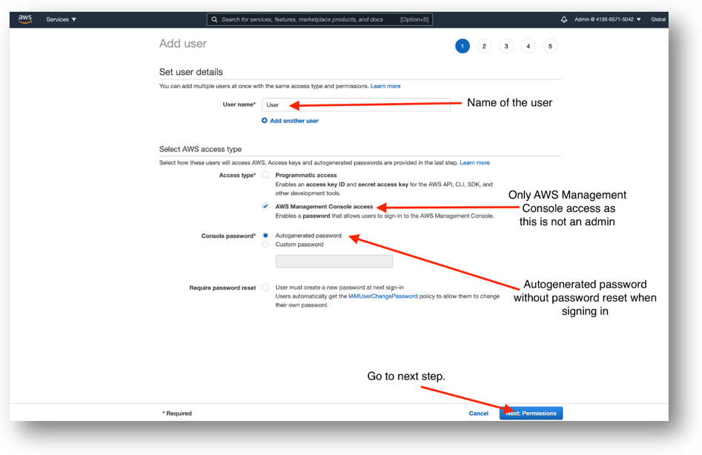

Figure 25. Step seven.

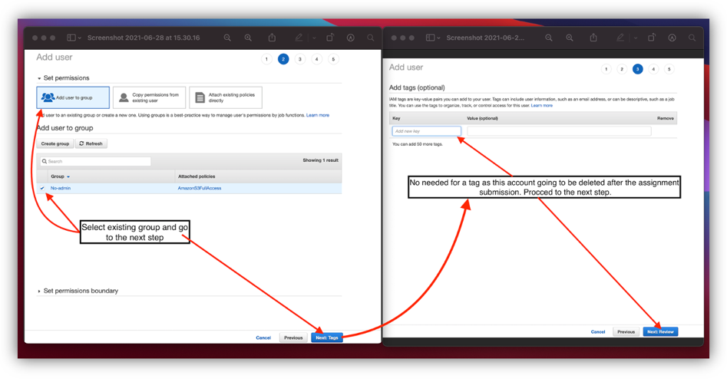

Figure 26. Step eight.

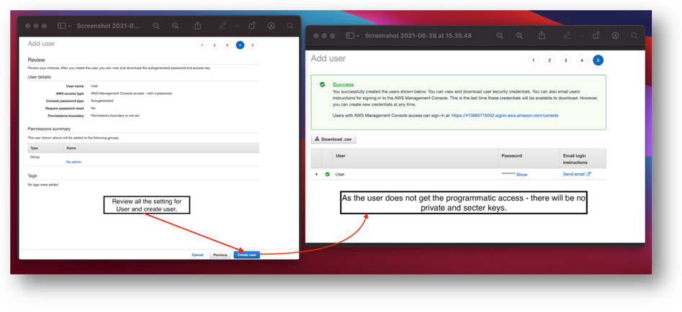

Figure 27. Finish.

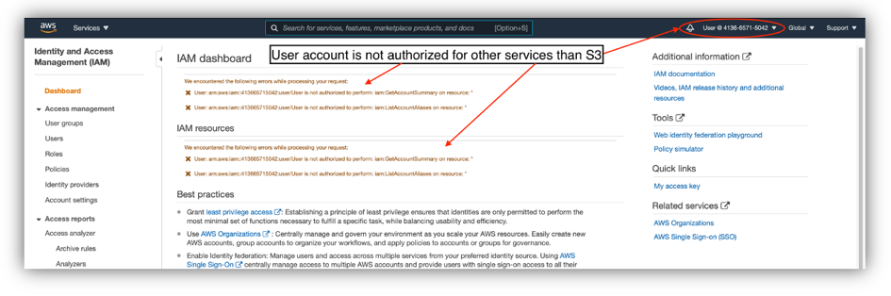

Figure 28. User not authorized.

## Amazon Elastic Compute Cloud (EC2)

The one of the strongest and frequently used Infrastructure as a Service (IaaS) within amazon AWS is EC2, which contribute scalable computing capacity, and it is an origin compute component technology stack (Arun, 2021). According to AWS (2021b) EC2 will erase all the need for hardware investment and deploy applications quicker.

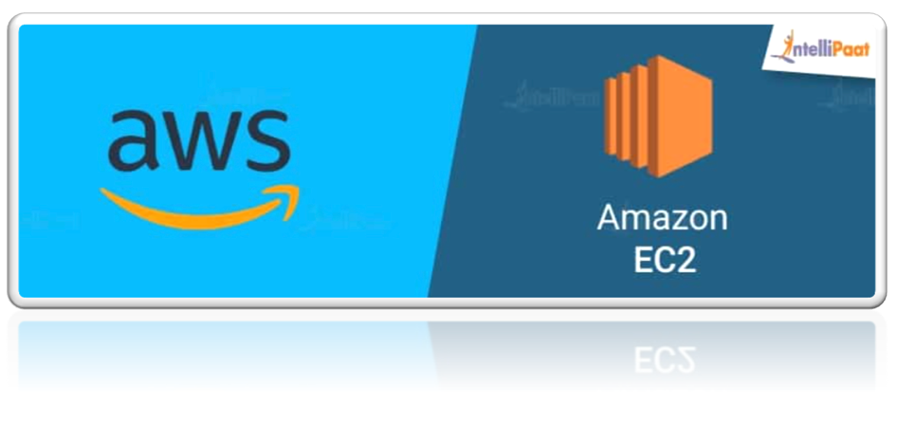

Figure . EC2 (Intellipaat, 2019a).

EC2 exactly like IAM is equipped with a wide range of features.

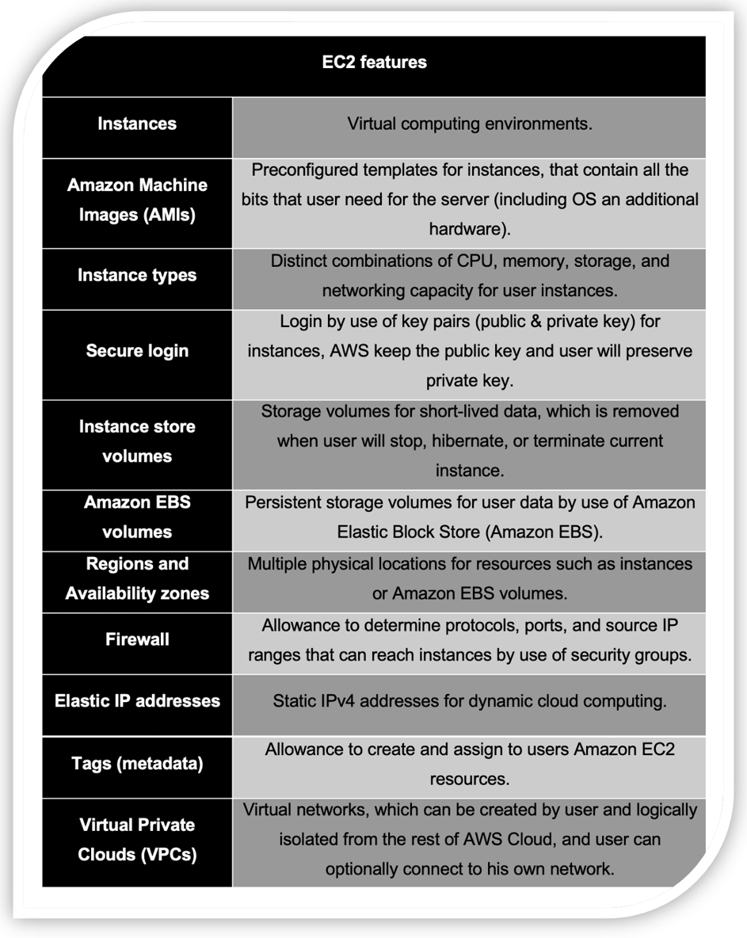

Figure . EC2 features (AWS, 2021b).

According to Arun (2021) EC2 is important in cloud computing due to its functionality.

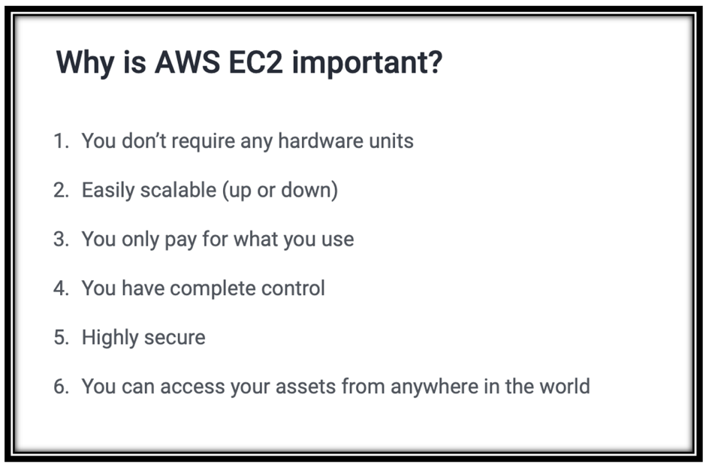

Figure . Importance of EC2 (Arun, 2021).

Amazon EC2 is a very good tool to work on instead of on-premises solutions, which is very expensive. According to Shereweb (2021) the on-premisses solutions cost include: server cost, electricity, and HVAC (heating, ventilation, and air-conditioning).

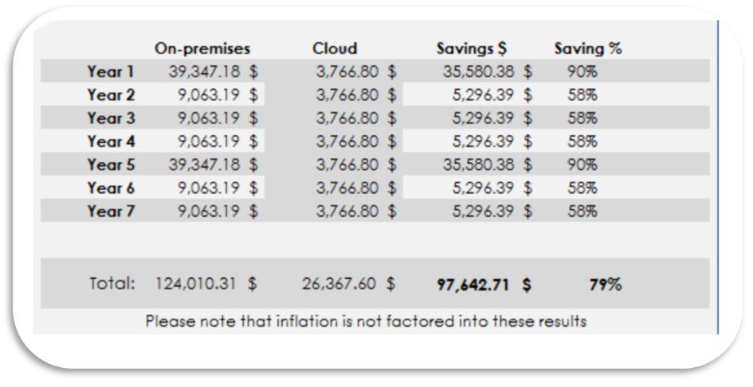

Figure . Comparison between on-premises solutions and IaaS (Shereweb, 2021).

The EC2 charges:

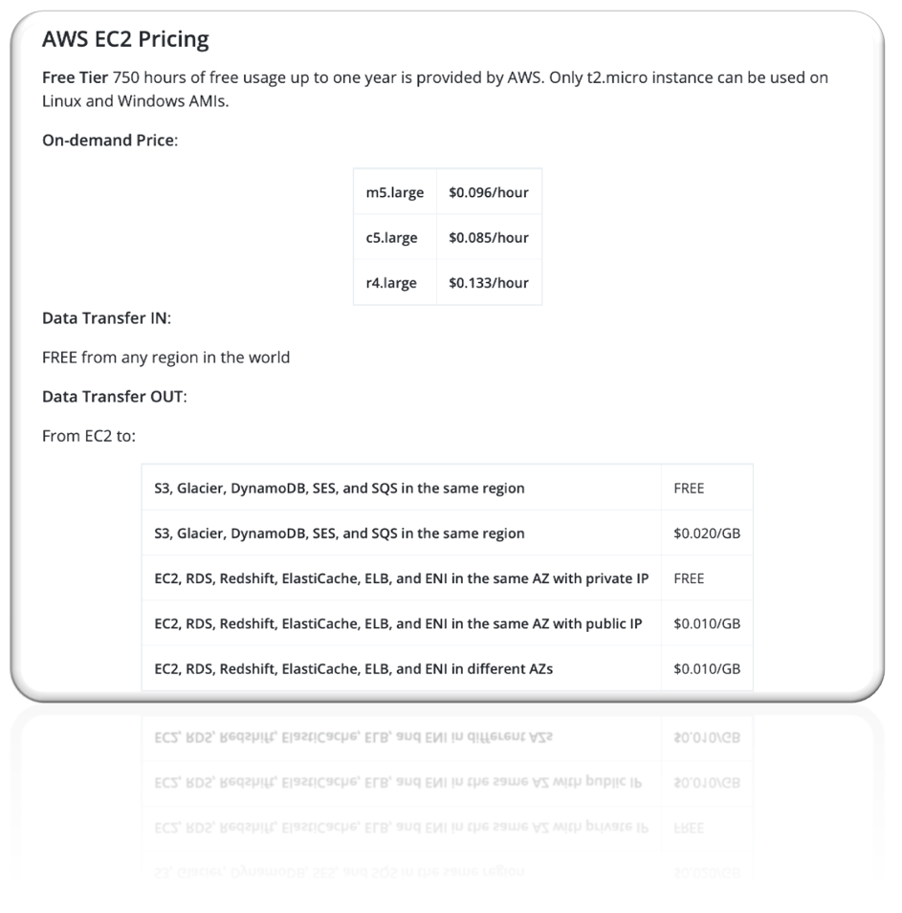

Figure . EC2 pricing (Intellipaat, 2019a).

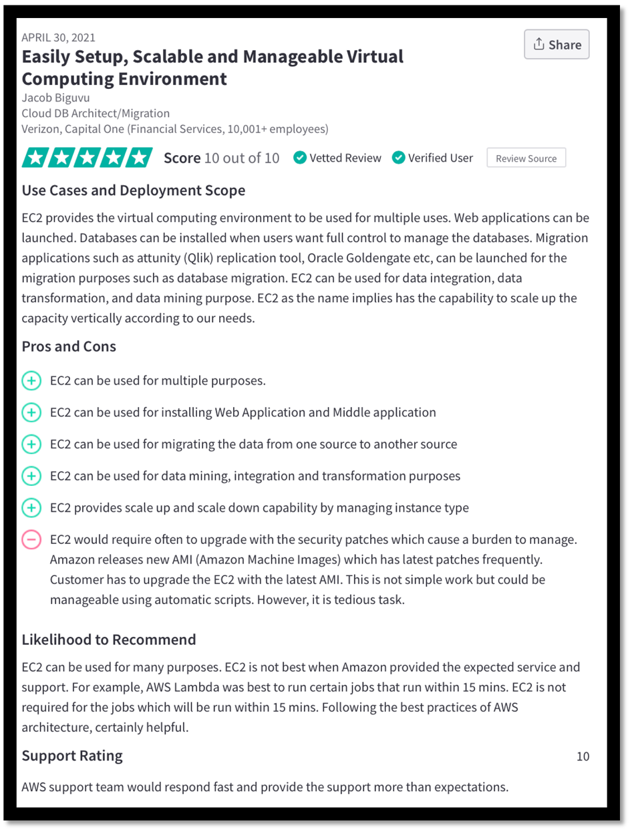

Figure . Review of EC2 (TrustRadius, 2021b).

Pros and cons:

+ ability to expand and shrink resources accordingly to the demand.

+ excellent buckup capabilities.

+ no hardware.

+ cost.

+ high performance.

+ scalable.

- require technical knowledge.

## Launching an Amazon EC2 Instance by admin.

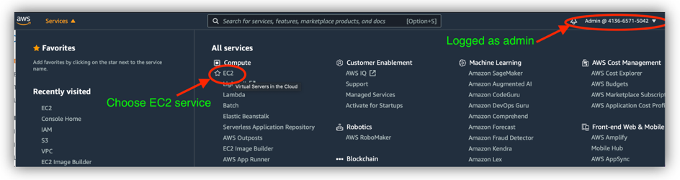

Figure . Opening EC2.

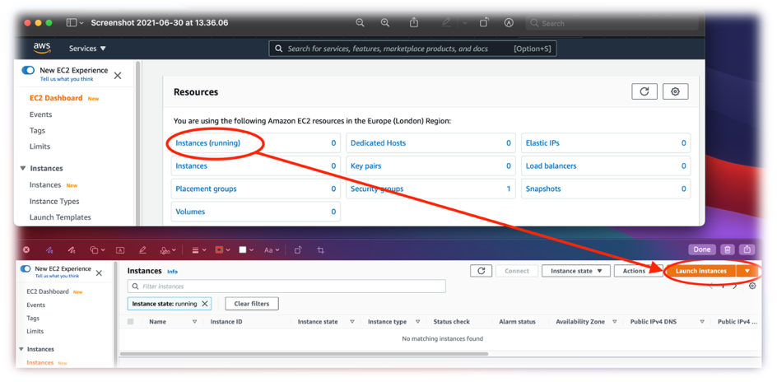

Figure . Launch Instance.

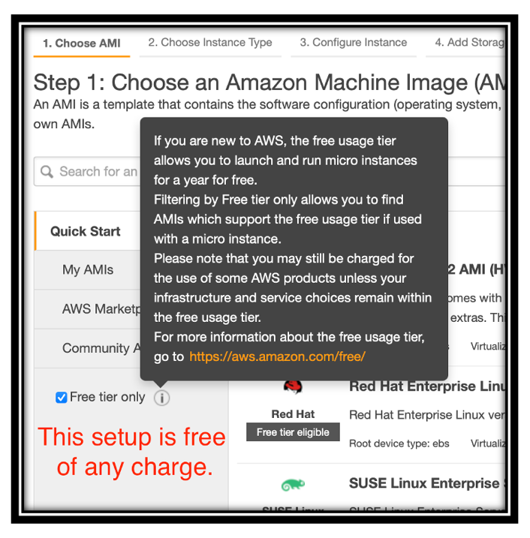

Figure . Free tier.

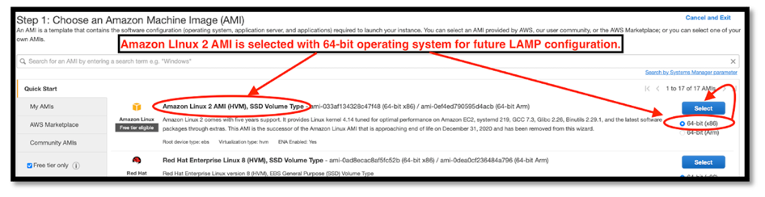

Figure . Amazon 2 AMI.

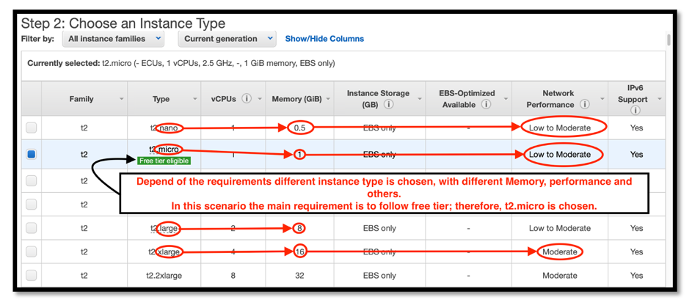

Figure . Instance Type.

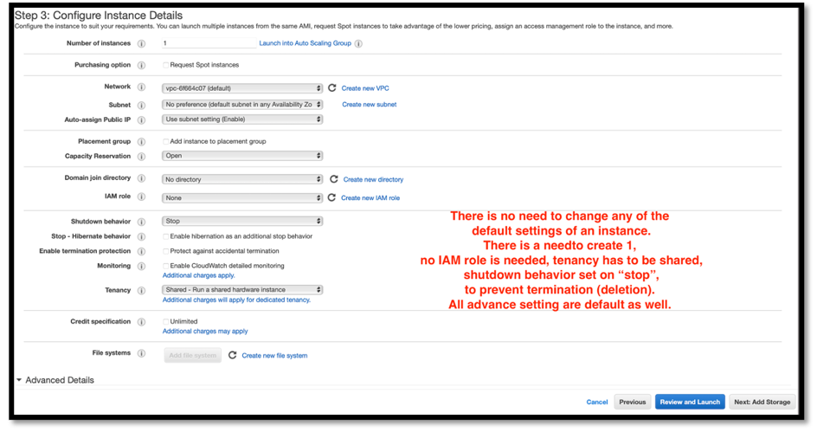

Figure . Instance details.

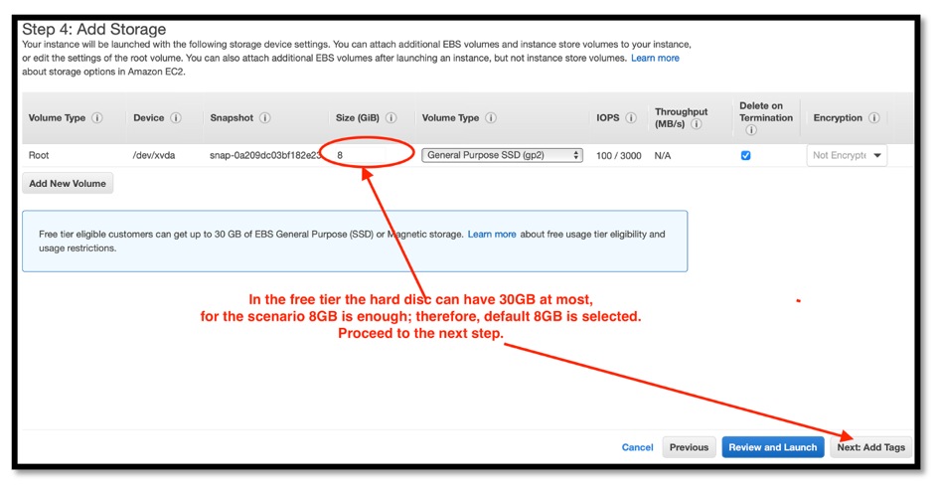

Figure . Storage.

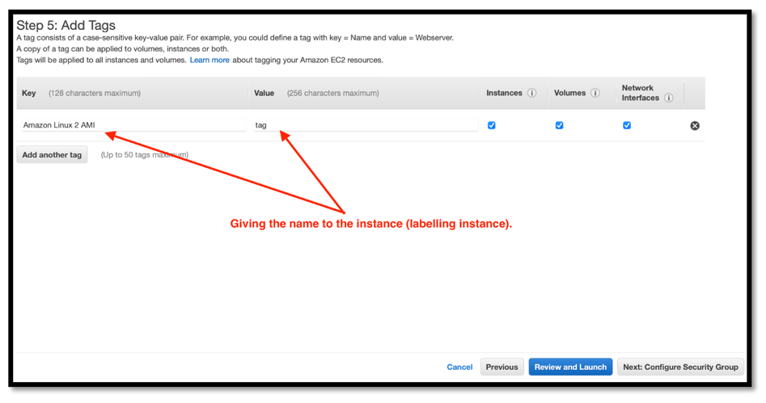

Figure . Instance tag.

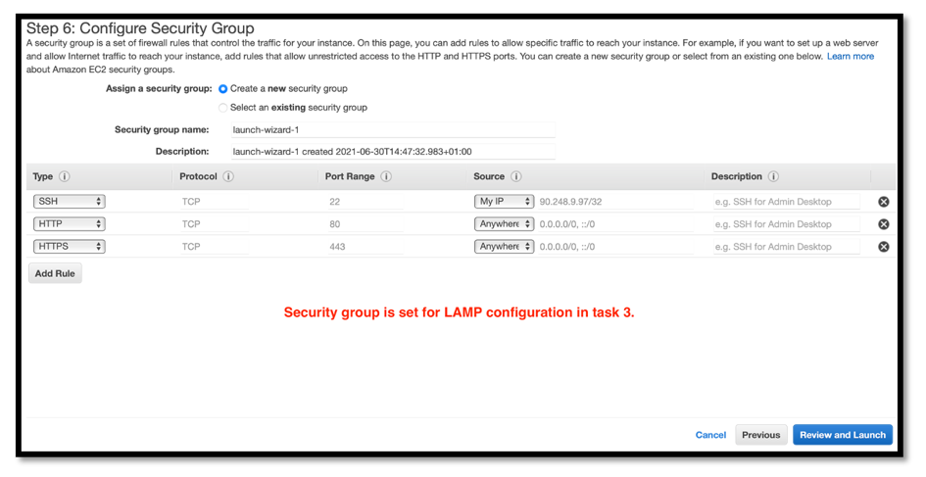

Figure . Security group.

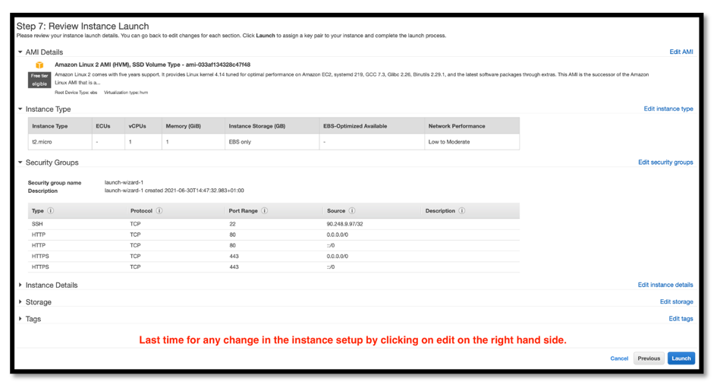

Figure . Instance review.

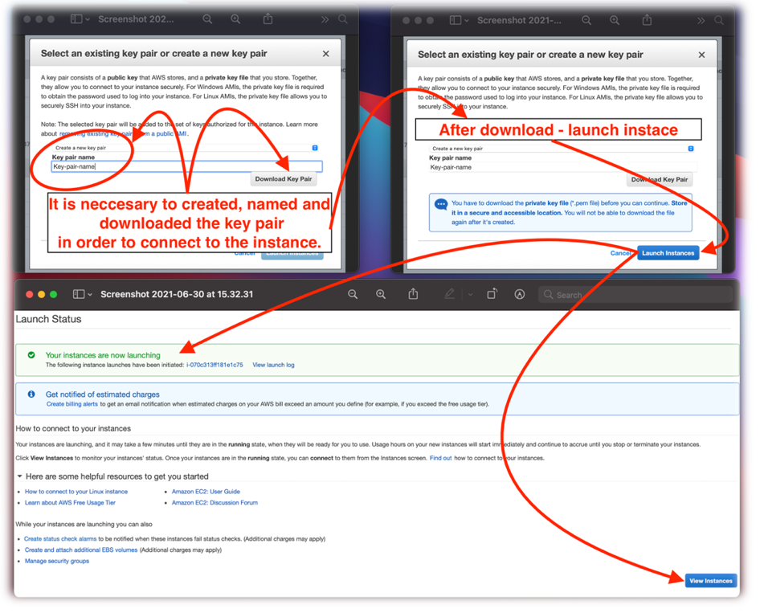

Figure . Key pair and launching.

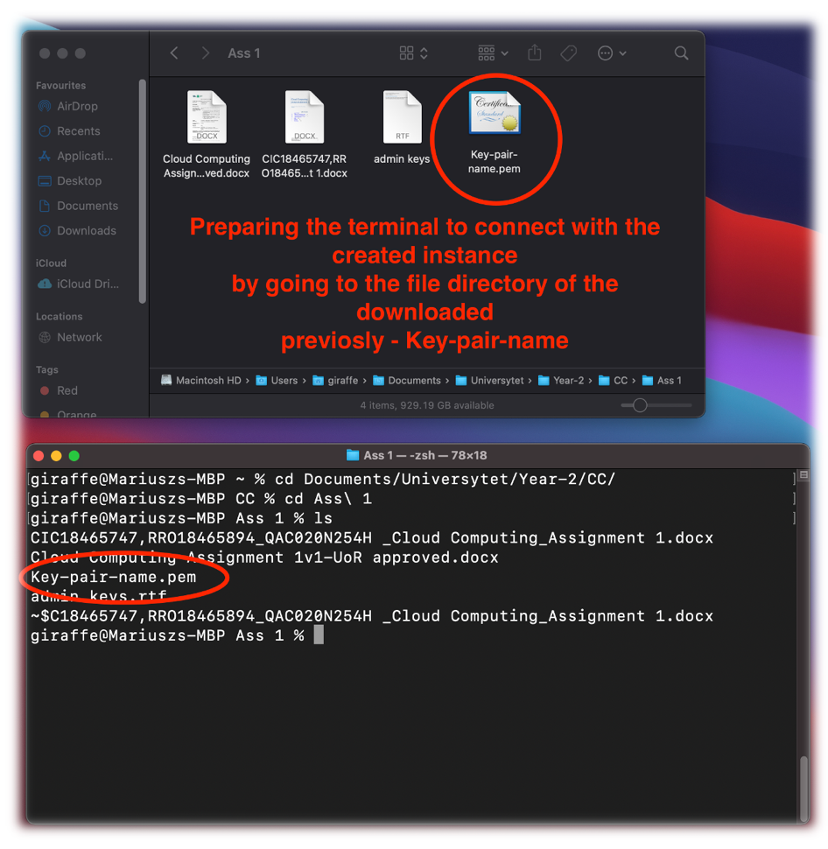

Figure . Terminal preparation.

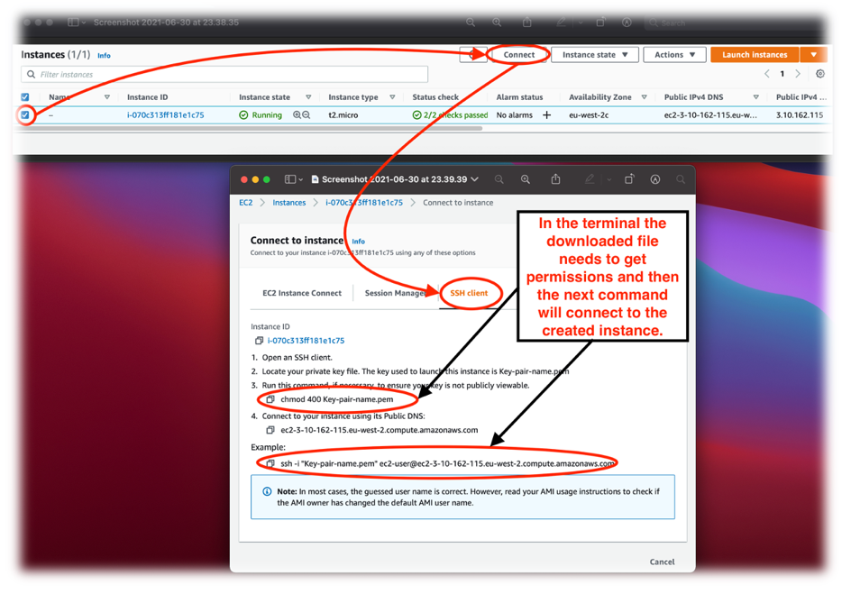

Figure . Getting the commands.

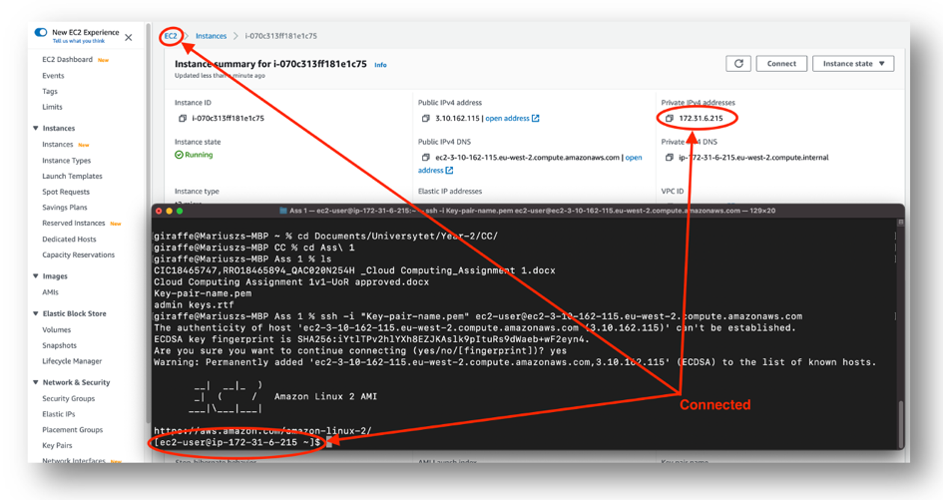

Figure . Connection established.

## Elastic Beanstalk service.

Figure 49. Elastic Beanstalk.

Elastic Beanstalk is a compute service that “helps” developers to deploy and manage their work quicker. Applications will be equipped with capacity provisioning, load balancing, auto-scaling, and heath monitoring; moreover, it can be uploaded on any platform (IntelliPaat, 2019b).

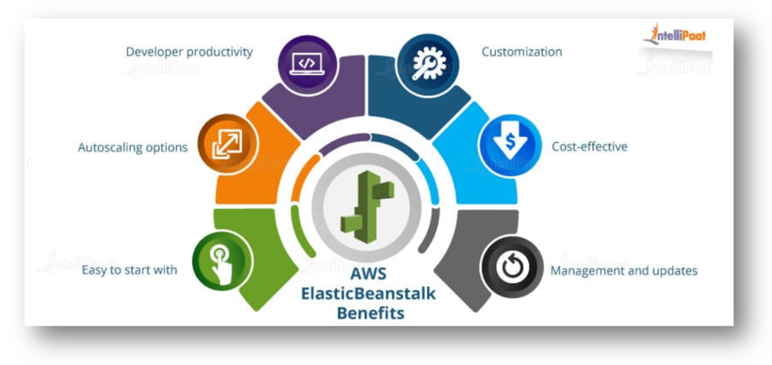

Figure 50. Benefits of Elastic Beanstalk (IntelliPaat, 2019b).

Features:

* Environment monitoring.
* Environment configuration.
* Application configuration and monitoring.
* Service integration.
* Management of environment.

Pros and cons:

+ fast and east upload applications.

+ auto-scaling.

+ good control of recourses.

+ good pricing.

# Task 2.

# Task 3.

Amazon SageMaker is a machine learning service. This service allows developers and data scientists create and train different machine learning models and employ them in a real-world environment in an easy and quick manner. (AWS Amazon, 2021)

Features:

* Machine learning service
* Jupyter authoring notebook
* Common algorithms
* Flexibility to bring your own algorithms

Pros and cons:

+ Adaptability to all levels, easy for beginners but complete enough for experienced users.

+ Only charged for what is used.

+ Customizable.

- Algorithms lack description.

- No mobile friendly.

- Does not allow to schedule trainings.

Conclusion:

Amazon SageMaker is an amazing tool for machine learning service which can help Artizan Limited expand their business in an efficient manner, allowing data scientists to understand and work with larger amounts of data. Although it has some downsides (which can be solved in future updates) Amazon SageMaker is a promising tool.

Amazon Cloudsearch is a service in the cloud which gives users an alternative easy to set up and manage to their searching tools. (AWS Amazon, 2021)

Features:

* Searching tool.
* Search web pages, document files, forum posts or other information.
* Able to search structured data or plain text.
* Manageable searching experience.

Pros and cons:

+ Manage and add capabilities to the search.

+ Fast queries.

+ Good reporting.

- Initial configuration tricky.

- Takes time to update values.

Conclusion:

Amazon Cloudsearch is a powerful searching tool which could help Artizan Limited search opinions or reviews on their products. Once the set up is done this service only has advantages, making searches faster and easier.

GuardDuty is security monitoring service that processes and analyses various sources of data such as DNS logs and CloudTrail data event logs for example. It contains lists with malicious IPs and domains, and with a machine learning service it unauthorizes possible threats. (AWS Amazon, 2021)

Features:

* Security monitoring tool.
* Use of threat intelligence feeds.
* Machine learning service to identify possible threats.
* Produces security findings for the user to see via console.

Pros and cons:

+ Security from possible threats.

+ Monitoring account access.

- No notifications on mobile.

- Hard to understand for unexperienced users.

Conclusion:

GuardDuty is a useful tool to keep security of the instances on track, and to secure them from future threats or attacks. There is not many downsides to this product therefore it is definitely a must for Artizan Limited, as their expansion to the e-commerce has to be as secure as possible.

References:

* AWS Amazon (2021). *What is Amazon SageMaker?* Available at: <https://docs.aws.amazon.com/sagemaker/latest/dg/whatis.html> [Accessed: 28/06/2021].
* AWS Amazon (2021). *What is Amazon Cloudsearch?* Available at: <https://docs.aws.amazon.com/cloudsearch/latest/developerguide/what-is-cloudsearch.html> [Accessed: 28/06/2021].
* AWS Amazon (2021). *What is Amazon GuardDuty?* Available at: <https://docs.aws.amazon.com/guardduty/latest/ug/what-is-guardduty.html> [Accessed: 28/06/2021].

# Conclusion.

IAM is a necessary service to operate and manage users on cloud, provides a wide range of functionalities, which make the usage of AIM significant. The only requirement of AIM is the time spend to learn about the features, but the outcome will make this service effective.

EC2 possess a variety of capable, compute-optimized instances with a performance-enhancing tools. Combined with Elastic Beanstalk to ease with all the operations on EC2, both together represent very strong and promising cloud services.

# Referencing.

* Alleyne, L. (2021) *The Impact of 5G on Cloud Computing.* Available at: <https://www.itbusinessedge.com/mobile/the-impact-of-5g-on-cloud-computing/> (Accessed: 9 June 2021).
* Arun, R. (2021) *What is AWS EC2 and Why It is Important?* Available at: <https://www.simplilearn.com/tutorials/aws-tutorial/aws-ec2> (Accessed: 20 June 2021).
* AWS (2021a) *What is IAM?* Available at: <https://docs.aws.amazon.com/IAM/latest/UserGuide/introduction.html> (Accessed: 20 June 2021).
* AWS (2021b) *What is Amazon EC2?* Available at: <https://docs.aws.amazon.com/AWSEC2/latest/UserGuide/concepts.html> (Accessed: 20 June 2021).
* AWS (2021c) *AWS Elastic Beanstalk.* Available at: <https://aws.amazon.com/elasticbeanstalk/> (Accessed: 4 July 2021).
* Carey, S. (2020) *AWS vs Azure vs Google Cloud: What’s the Best Cloud platform for Enterprise?* Available at: <https://www.computerworld.com/article/3429365/aws-vs-azure-vs-google-whats-the-best-cloud-platform-for-enterprise.html> (Accessed: 13 June 2021).
* DeBrie, A. (2018) *AWS IAM Policy.* Available at: <https://www.msp360.com/resources/blog/aws-iam-policy/> (Accessed: 13 June 2021).
* Feldman, S. (2019) *The Cloud Market Keeps Moving Upwards.* Available at: <https://www.statista.com/chart/19039/cloud-infrastructure-revenue/> (Accessed: 9 June 2021).
* Intellipaat (2019a) *What is EC2 in AWS? – Amazon EC2 Tutorial.* Available at: <https://intellipaat.com/blog/what-is-amazon-ec2-in-aws/> (Accessed: 20 June 2021).
* IntelliPaat (2019b) *What is AWS Elastic Beanstalk?* Avaialble at: <https://intellipaat.com/blog/what-is-elastic-beanstalk-in-aws/#what-is-beanstalk> (Accessed: 1 July 2021).
* Lujan, V. (2018) *What is Cloud IAM?* Available at: <https://jumpcloud.com/blog/what-is-cloud-iam> (Accessed: 13 June 2021).
* Microsoft Azure (2021) *What is Cloud Computing?* Available at: <https://azure.microsoft.com/en-gb/overview/what-is-cloud-computing/#benefits> (Accessed: 9 June 2021).
* Nikolaisen, N. (2021) *What is Identity and Access Management?* Available at: <https://www.tenfold-security.com/en/identity-and-Access-Management/?GA_campaign=13173348172&GA_adgroup=121970816825&GA_keyword=what%20is%20iam&GA_network=g&GA_device=c&GA_target=&GA_placement=&GA_creative=522862795151&GA_extension=&GA_loc_physical_ms=9045957&GA_landingpage=%7BURL%7Dhttps://www.tenfold-security.com/identity-and-Access-Management/&gclid=Cj0KCQjw2NyFBhDoARIsAMtHtZ6sk-8H5mkDyYGkyOGSQpkj9RLUJePD8C1y19hgH0b6Ihn9lA0JndsaApQ5EALw_wcB> (Accessed: 13 June 2021).
* Poccia, D. (2020) *Now Open – Third Availability Zone in the AWS Canada (Central) Region.* Available at: <https://aws.amazon.com/blogs/aws/now-open-third-availability-zone-in-the-aws-canada-central-region/> (Accessed: 9 June 2021).
* Richter, F. (2021) *Amazon Leads $130-Billion Cloud Market.* Available at: <https://www.statista.com/chart/18819/worldwide-market-share-of-leading-cloud-infrastructure-service-providers/> (Accessed: 9 June 2021).
* Shareweb (2021) *Cost of Server Ownership: On-premises vs IaaS.* Available at: <https://www.sherweb.com/blog/cloud-server/total-cost-of-ownership-of-servers-iaas-vs-on-premise/> (Accessed: 20 June 2021).
* TrustRadius (2021a) *AWS Identity & Access Management Reviews.* Available at: <https://www.trustradius.com/products/aws-identity-access-management/reviews?o=recent> (Accessed: 20 June 2021).
* TrustRadius (2021b) *Amazon Elastic Compute Cloud (EC2) Reviews.* Available at: <https://www.trustradius.com/products/amazon-elastic-compute-cloud-ec2/reviews> (Accessed: 20 June 2021).

# Table of figures.

Figure 1. CC growth in 2016-2019 (Feldman, 2019). 3

Figure 2. Detailed reasons of CC's growth (Microsoft Azure, 2021). 4

Figure 3. Cloud market leaders (Richter, 2021). 5

Figure 4. AWS regions (Poccia, 2020). 6

Figure 5. Why cloud IAM (Lujan, 2018). 7

Figure 6. Key concepts (DeBrie, 2018). 8

Figure 7. IAM features (AWS, 2021a). 9

Figure 8. IAM review (TrustRadius, 2021a). 10

Figure 9. Choosing IAM from services. 12

Figure 10. Region. 12

Figure 11. IAM dashboard. 13

Figure 12. User creation. 13

Figure 13. Step one for admin creation. 14

Figure 14. Step two. 15

Figure 15. Step three. 16

Figure 16. Step four. 17

Figure 17. Step five. 18

Figure 18. Confirmation. 18

Figure 19. Step one for no-admin user creation. 19

Figure 20. Step two. 20

Figure 21. Step three. 20

Figure 22. Step four. 21

Figure 23. Step five. 21

Figure 24. Step six. 22

Figure 25. Step seven. 23

Figure 26. Step eight. 24

Figure 27. Finish. 24

Figure 28. User not authorized. 25

Figure 29. EC2 (Intellipaat, 2019a). 26

Figure 30. EC2 features (AWS, 2021b). 27

Figure 31. Importance of EC2 (Arun, 2021). 28

Figure 32. Comparison between on-premises solutions and IaaS (Shereweb, 2021). 29

Figure 33. EC2 pricing (Intellipaat, 2019a). 30

Figure 34. First review of EC2 (TrustRadius, 2021b). 31

Figure 35. Opening EC2. 32

Figure 36. Launch Instance. 32

Figure 37. Free tier. 33

Figure 38. Amazon 2 AMI. 34

Figure 39. Instance Type. 34

Figure 40. Instance details. 35

Figure 41. Storage. 35

Figure 42. Instance tag. 36

Figure 43. Security group. 36

Figure 44. Instance review. 37

Figure 45. Key pair and launching. 38

Figure 46. Terminal preparation. 39

Figure 47. Getting the commands. 40

Figure 48. Connection established. 41

Figure 49. Elastic Beanstalk. 42

Figure 50. Benefits of Elastic Beanstalk (IntelliPaat, 2019b). 42